PROJECT REPORT FOR: E-VOTING

project submitted BY: | trainer NAME:
- RAKESHA B R  - JAGDEESH S  3. MANJUNATH H  4. SIDDARAJU  5. SHIVAKUMAR | Venkatasubramanian r

Software Development Document

Overview
Electronic voting (also known as e-voting) is voting that uses electronic means to either aid or take care of casting and counting votes.
Project Objectives
To produce a web-based application that would be able to vote the in any corner of the country.with only using the internet and your adhar number of their own.So it is easy to put the vote even your in the outer country.

ROLES AND RESPONSIBILITIES

NAM E | ROLE | CONTACT INFORMATION | SIGNATURE
Rakesha b r | Team member | Rakeshbr1219@gmail.com | Rakesha b r
Manjunath h | Team member | Manjunath1998@gmail.com | manjunatha
Siddaraju k s | Team member | siddarajuprince@gmail.com | siddaraju
Jagadeesh s | Team member | Jagadeeshmeenamanu98@gmail.com | jagadeesh
shivakumar | Team member | Shivakumar1234@gmail.com | shivakumar

PROCESS
In this process user have to login through the distric ID so that we can find our candidates in the page, after that we can vote through our adhar number which is given by the central government.
After you enter the adhar number it should be verified by the software if that particular adhar number is present in the database ,after verifying the adhar it is going to be check if the user is already voted or not if the people is already voted it gives the popup message like you are already voted. And if not voted they have their own option like vote for that particular member.
Requirements
- Python
- Django
- PC
- SQL Lite 3
Functionality
Association between User and Tasks
Association between User and Status

Source Code( views.py):
from django.shortcuts import render,redirect
#from django.shortcuts import render
from django.http import HttpResponse
from .models import constituency,Voter_id,Aadhar_card,contestent,E_officer

def home0(request):
usr_check=E_officer.objects.all()
if request.method == 'POST':
e_user_id = request.POST['e_user_id']
e_pwd = request.POST['e_pwd']
for usr in usr_check:
if(usr.e_oname==e_user_id and usr.e_password==e_pwd):
return render(request,"home.html",{"usr":usr})
msg="Invalid OFFICER USER ID or PASSWORD..!"
back='home0'
return render(request,'error.html',{'msg':msg,'back':back})
return render(request,'home0.html')

def home(request,pk):
usr=E_officer.objects.filter(id=pk).first()
return render(request,'home.html',{"usr":usr})

def vote(request,pk):
usr=E_officer.objects.filter(id=pk).first()
if request.method == 'POST':
a_num = request.POST['a_num']

temp=Aadhar_card.objects.filter(Aa_number_id=a_num).first()
if temp == None :
msg="Aadhar id is invalid..!"
back='vote'
return render(request,'error.html',{'msg':msg,'back':back,"usr":usr})
elif temp.voted == True:
msg="You have already voted..!"
back='vote'
return render(request,'error.html',{'msg':msg,'back':back,"usr":usr})
else:
return redirect("details",pk=temp.id,pku=usr.id)
return render(request,'vote.html',{"usr":usr})

def details(request,pk,pku):
usr=E_officer.objects.filter(id=pku).first()
single_adhar=Aadhar_card.objects.filter(id=pk).first()
temp_c_id=single_adhar.v_VID.c_CID
contestents= contestent.objects.filter(const_Id=temp_c_id)
return render(request,'details.html',{'single_adhar':single_adhar,'contestents':contestents,"usr":usr})

def cast(request,pkcn,pka,pku):
usr=E_officer.objects.filter(id=pku).first()
s_a=Aadhar_card.objects.filter(id=pka).first()
s_c=contestent.objects.filter(id=pkcn).first()

#s_a.v_VID.voted=True
vote=contestent.objects.filter(id=pkcn).first().votes+1
Aadhar_card.objects.filter(id=pka).update(voted=True)
contestent.objects.filter(id=pkcn).update(votes=vote)

msg="You have casted your vote succesfully..!"
back='vote'
return render(request,'cast.html',{'msg':msg,'back':back,"usr":usr})

def electrol(request,pk):
nv=0
e_a=E_officer.objects.filter(id=pk).first()
contestents= contestent.objects.filter(const_Id=e_a.e_cid)
for cn in contestents:
nv=nv+cn.votes
return render(request,'electrol.html',{"contestents":contestents,"e_a":e_a,"nv":nv})

Libraries, Tables
Here we import some of the libraries from the django, Django.db, models, Django.contrib,auth.models,Django.test,Django.http ETC.

Development Methodologies
Signup session
Here we add new user details and to sign in the after login page will be open to login to their task details.
Login session
Every user must login by his user name and password. After clicking on Log in button codes behind the page will call a method of User Manager class, Check User Id And Password(user ID, password), which takes user ID and password as parameter check it with database if any match found returns user type. If no match found this method will return empty string and which conclude as wrong password. Code also adds a session variable which is user id.
User session
User can add a task , if the task is completed then delete that task at the last the table remains a task which is not done on that day.Place a checkmark to the left of the question when it is determined that the programming methodology descriptions are all included in the folder.

Test Data
In this session we used some test data with and we got some problems those are
We got a problem that the field we update is not affect into the database then we gone through the code then we correct problem by add function.

Test Analysis
In analysis we decided to add the columns like id, password, and email for login and task column and then complete column to check whether the task is done or not.

Sign-Off –
Date and sign the certification for completion of coding and unit testing for the module.

These are the output
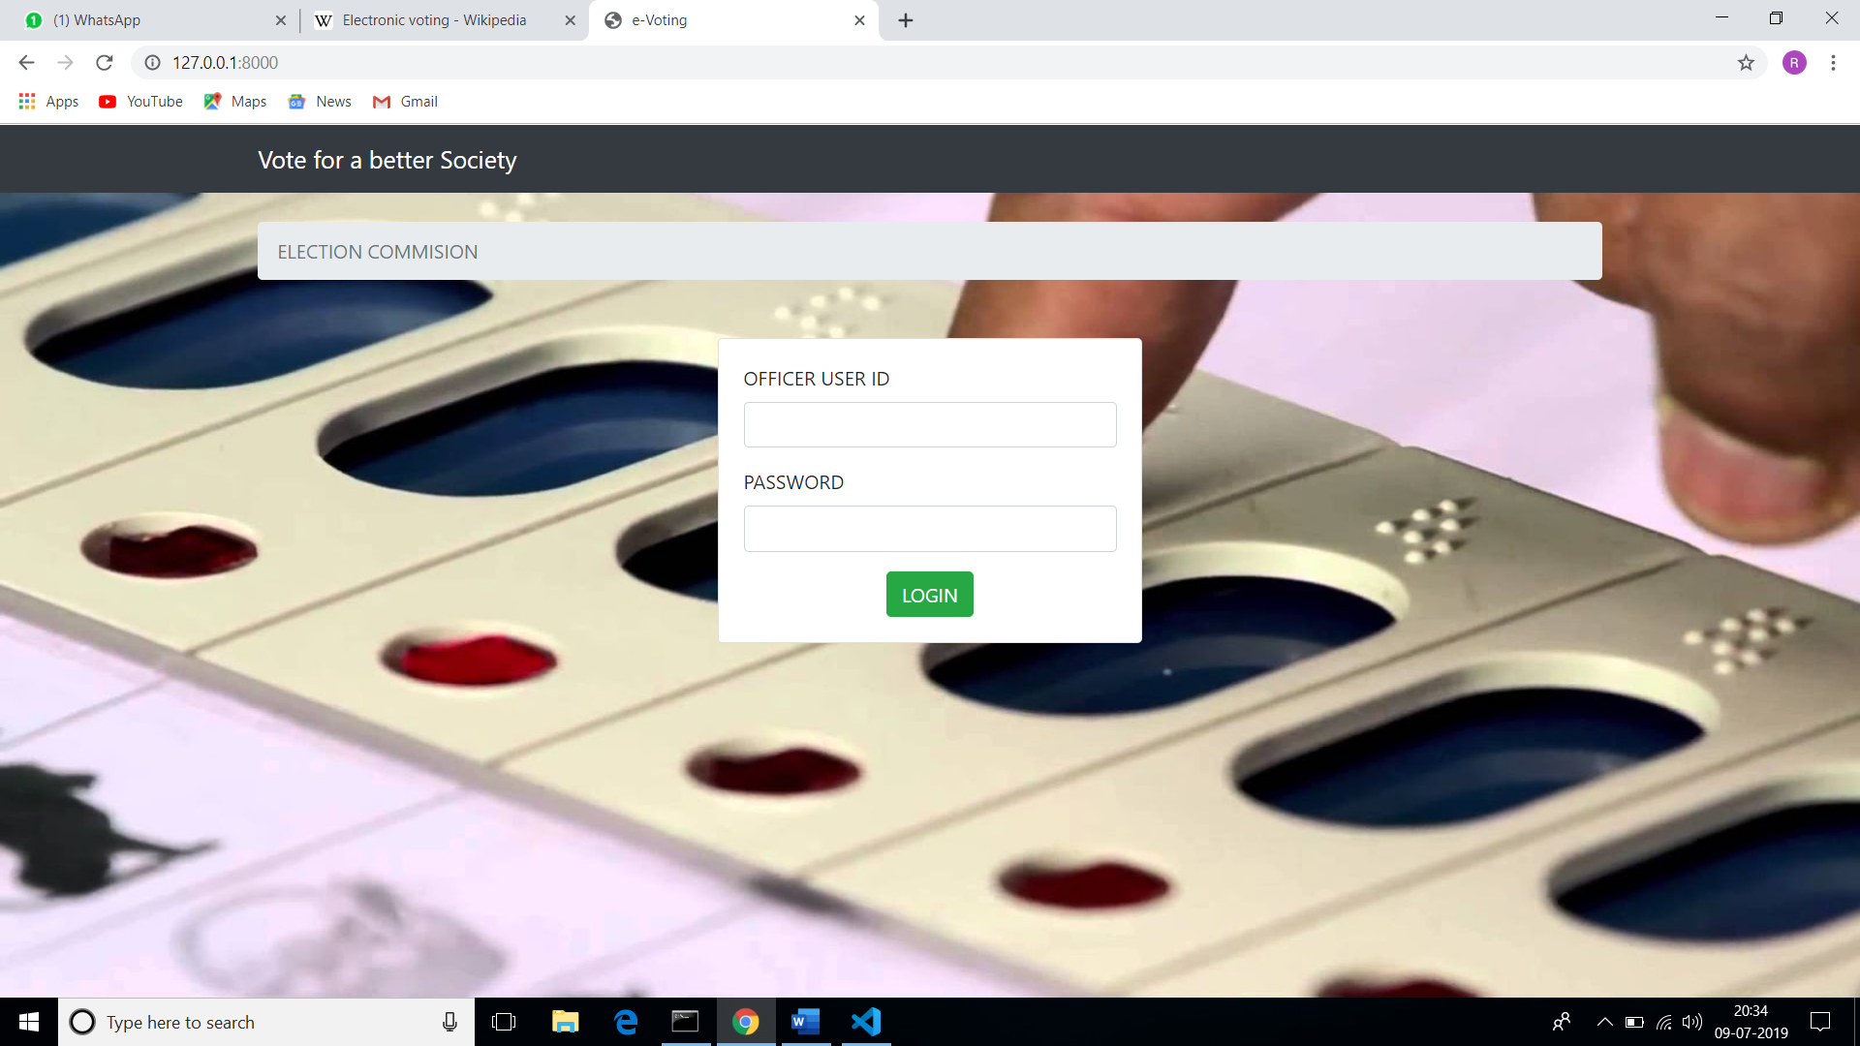

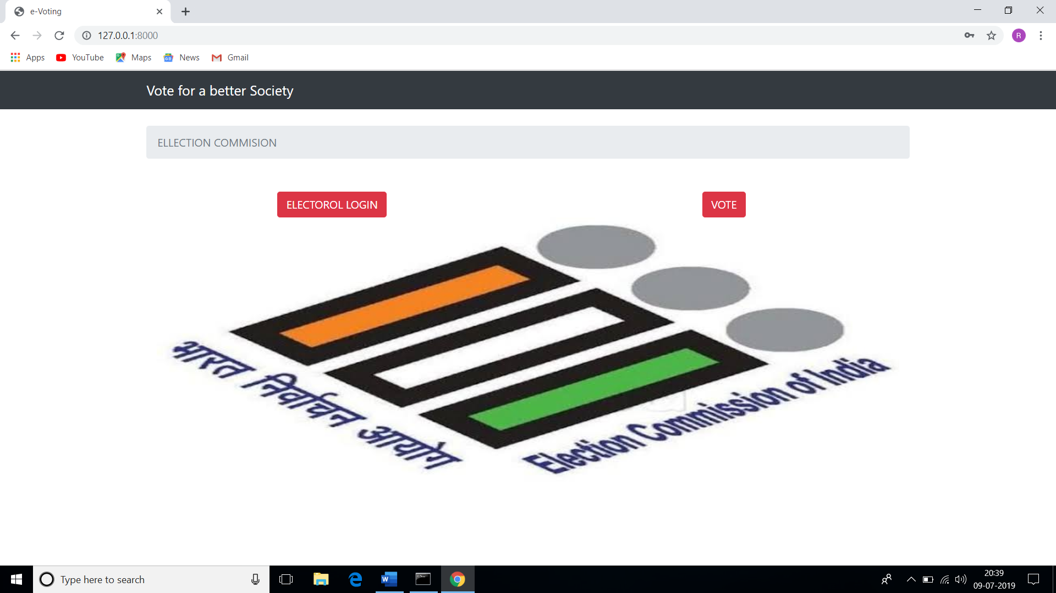

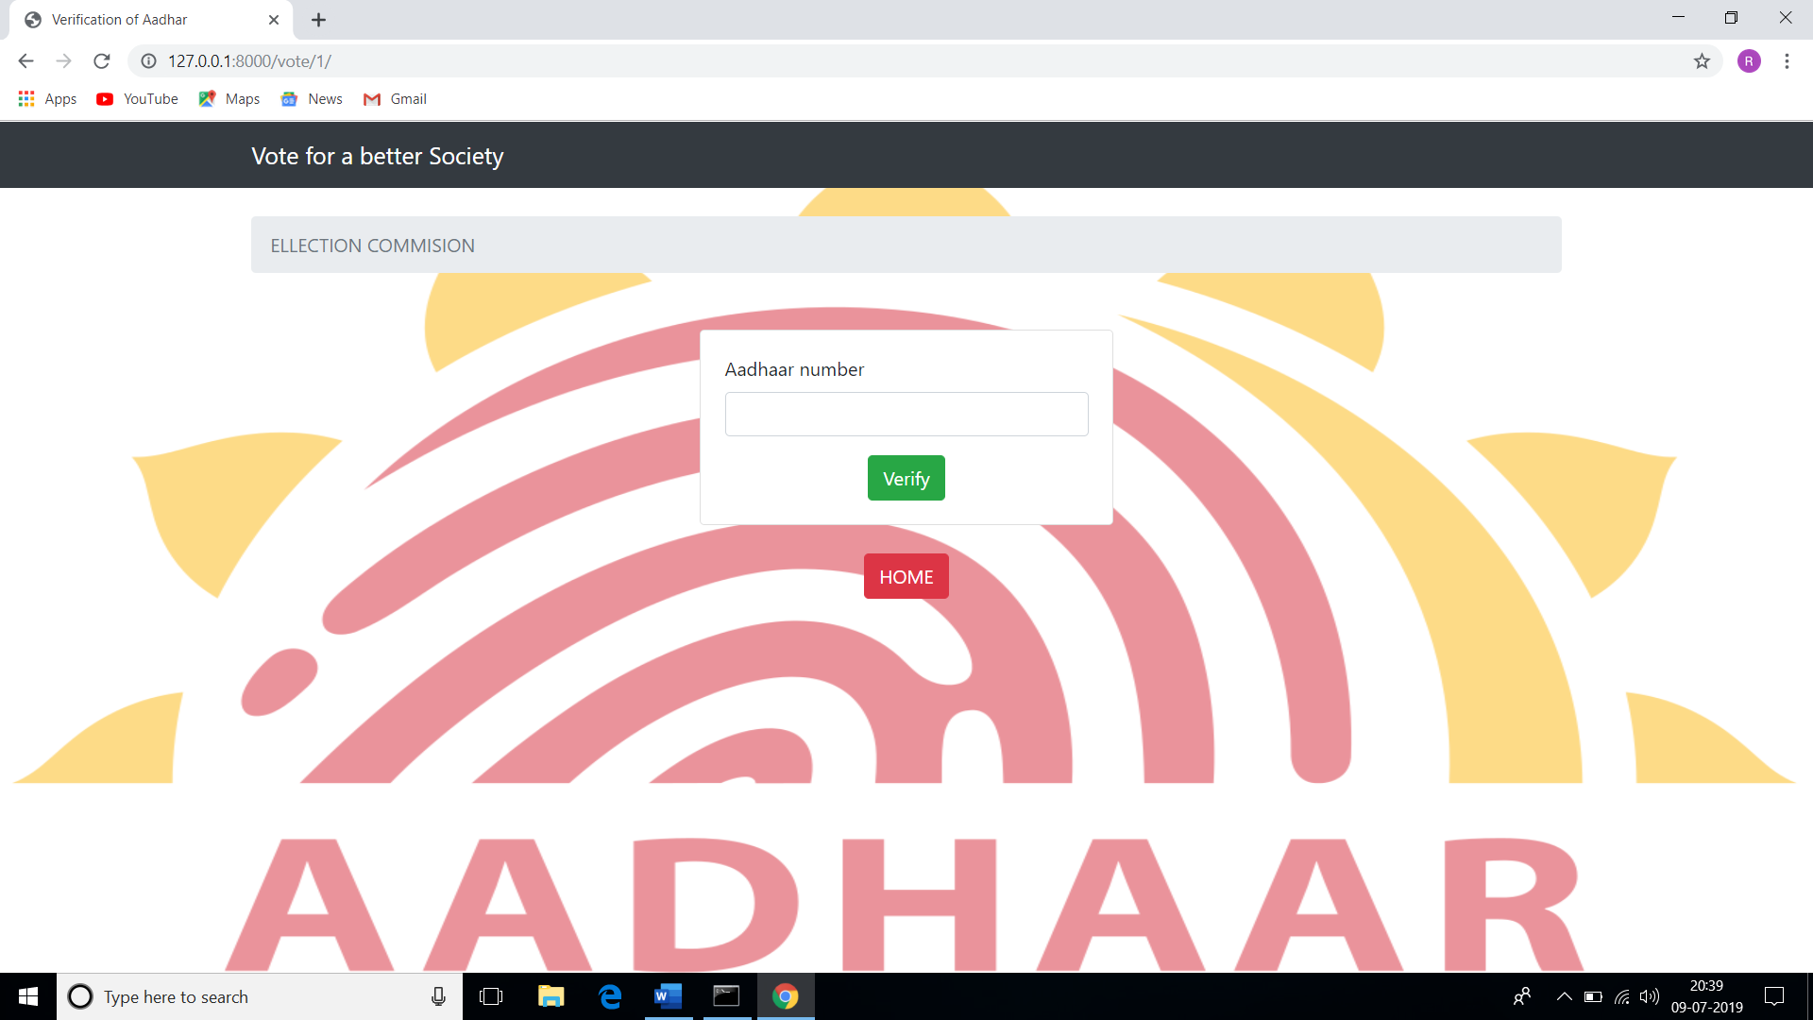
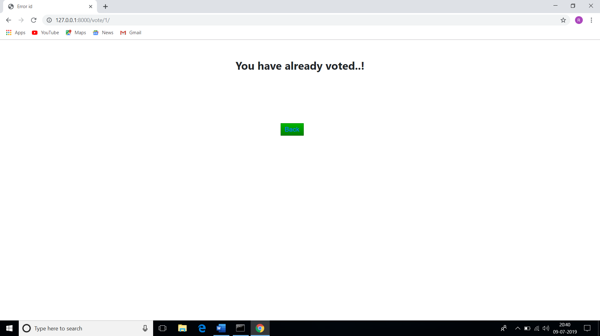

System Developer

I certify that this software development document is complete, the unit task manager defined in this folder has successfully completed development and unit testing, and the unit is ready to be base lined and integrated into the system

Date: 10/07/2019 System Developer: rakesha b r,
manjunath h,
Jagdeesh s,
siddaraju k s,
shivakumar,

System Technical Lead Initials: _____________

